

Astley Village Parish Council

PLANTING AT THE ASTLEY VILLAGE GARDEN OF REFLECTION

The Parish Council recently created a Garden of Reflection in Astley Village including the planting of commemorative trees and new paths.

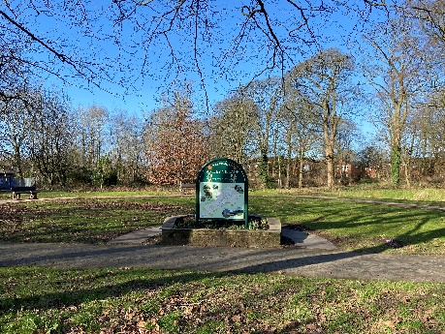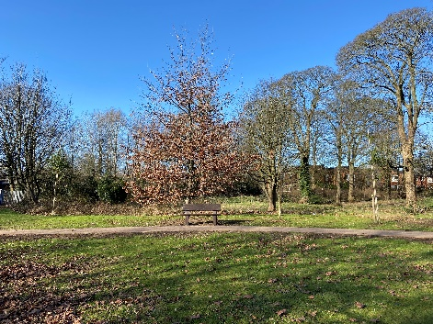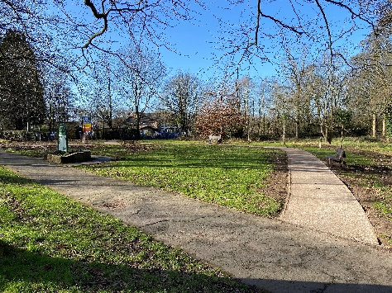

We would like to invite you to tender for the additional planting based on the specification below.

SPECIFICATION

Remove existing shrubs in raised planter (A, B) and retain for reuse where possible. Dig over soil and remove old bulbs to tip. Remove turf from area C (approx. 0.8m width) and D (approx. 1.5m width) to tip. Dig over soil to depth of 500mm where possible. Remove any clay and large stones to tip. Dig in 4 large bags of compost and 1 large bag of fertiliser to all soiled planting areas. Please refer to the associated Site location plan, site design and planting schedule at the Appendix to this report.

Supply the plants and bulbs as outlined in the planting/costing schedule below and plant to the design supplied.

Supply mulch and spread on planting area A, B and D. any leftover mulch to be spread around adjacent planting beds and trees.

Supply and spread small golden gravel to planting area C

Make good the surrounding ground, sweep and tidy the path and leave in a neat clean condition.

Proposed Planting Schedule for Astley Village Community Garden
Area A – part of raised bed facing the road
Code | Plant | Pot Size | Height | Number
S1 | Hebe pinguinifolia Pagei | 2L | 10/20cm | 2
S2 | Potentilla fruiticosa Red Ace | 5L | 30/40 | 1
B1 | Narcissi Tanzetta |  |  | 25
B2 | Crocus Tommasinia |  |  | 30
Area B – part of raised bed facing towards the garden
Code | Plant | Pot Size | Height | Number
S3 | Choysia ternata Aztec Pearl | 5L | 30/40 | 1
S4 | Hebe (veronica) Champagne | 5L | 30/40 | 1
S5 | Lavandula angustifolia Hidcote | 3L | 30/40 | 7
B1 | Narcissi Tanzetta |  |  | 40
B2 | Crocus Tommasinia |  |  | 30
Area C - narrow border around planter
Code | Plant | Pot Size | Height | Number
S6 | Thyme Doone Valley | 5L | 30/40 | 12
S7 | Thyme Pink Chinz | 5L | 30/40 | 12
Area D – new border to be viewed from both sides
Code | Plant | Pot Size | Height | Number
S8 | Berberis thunbergii atropurpurea Admiration | 5L | 30/40 | 20
S9 | Rosa Remember Me (HT) | 5L | 30/40 | 12
S10 | Rosa Peace (HT) | 5L | 30/40 | 12
B3 | Narcissi Tranthus |  |  | 75
B4 | Crocus Cream Beauty |  |  | 75
KEY
S | Shrubs
T | Tree
Og | Ornamental Grass
B | Bulbs

Please return your total cost (with breakdown for labour, the supply the plants and bulbs and other materials to the Parish Clerk via email at clerk@avpc.org.uk by Friday 31 January 2025 at 6pm.

